**LTE**

**Theoretical Laboratory Session**

Wireless Communications 371-1-1903

Spring 2019

# Part 1 - Connection establishment

## **General Theoretical Information**

In this part we will go through all the stages of connection establishment procedures. On power on, the UE begins by running the procedure for network and cell selection, which has three steps:

* In the first step, the mobile selects a public land mobile network (PLMN) that it will register with.
* In the second step, the mobile can optionally ask the user to select a closed subscriber group (CSG) for registration.
* In the third, the mobile selects a cell that belongs to the selected network and if necessary to the selected CSG. In doing so, it is said to camp on the cell.

The mobile then contacts the corresponding base station using the contention-based random

access procedure and initiates the procedure for RRC connection establishment. During the

RRC procedure, the mobile establishes a signaling connection with the selected base station.

In the final step, the mobile uses the attach procedure to contact the evolved packet core.

The mobile is now in the states EMM-REGISTERED, ECM-CONNECTED and RRC_CONNECTED, and will stay in those states for as long as it is exchanging data with the network.

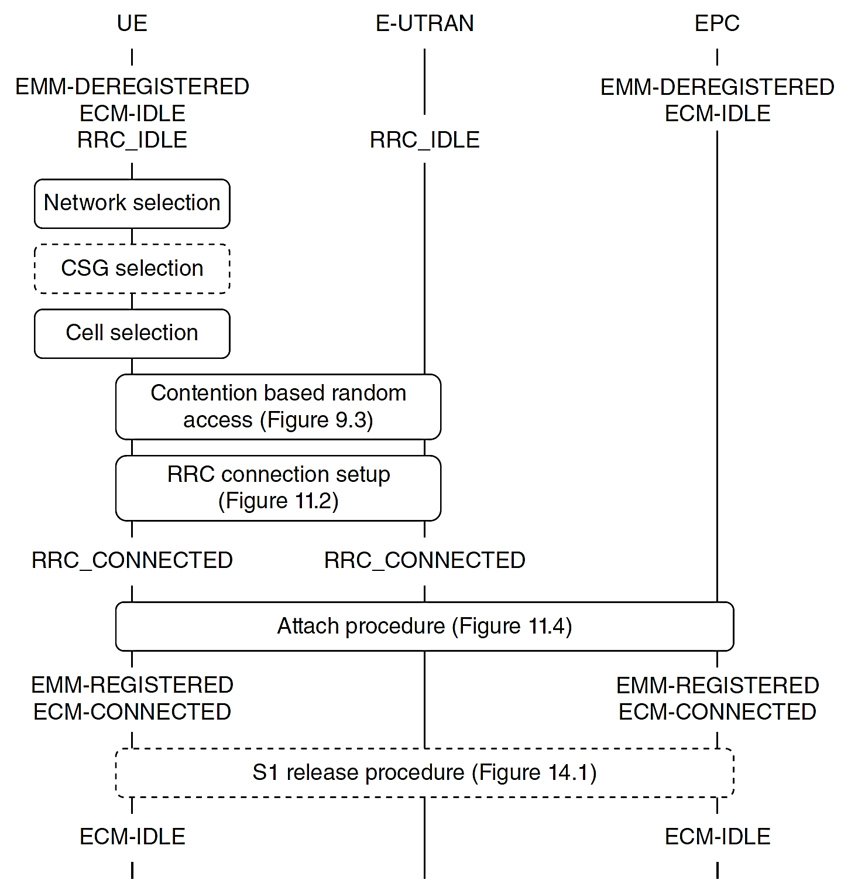

Figure 1 Overview of the mobile’s power-on procedures

## **Network and Cell Selection**

In the network selection procedure, the mobile selects a public land mobile network (PLMN) that it will register with. To start the procedure, the mobile equipment interrogates the USIM and retrieves the globally unique temporary identity (GUTI) that it was using when last switched on, as well as the tracking area identity in which it was registered. From these quantities, it can identify the corresponding network, which is known as the registered PLMN.

The mobile runs the CSG and cell selection procedures, in the hope of finding a suitable cell that belongs to the registered PLMN. If the mobile cannot find the registered PLMN, then it scans all the LTE carrier frequencies that it supports and identifies the networks that it can actually find.

If the USIM contains any closed subscriber groups, then the mobile has to run an additional procedure, known as CSG selection.

During the cell selection procedure, the mobile selects a suitable cell that belongs to the selected network and, if necessary, to the selected closed subscriber group. If carrier information is unknown or unavailable, then the mobile scans all the LTE carrier frequencies that it supports and identifies the strongest cell on each carrier that belongs to the selected network.

*Resources*

<https://en.wikipedia.org/wiki/SIM_card#USIM>

<https://en.wikipedia.org/wiki/Public_land_mobile_network>

<http://www.numberportabilitylookup.com/networks?s=>

<https://en.wikipedia.org/wiki/Closed_subscriber_group>

## **Theory Questions**

1. What is USIM? Why do we need it? Describe several paraments contained within the USIM?
2. What are ICCID, IMSI, Ki, LAI, IMEI? Why do we need them? Do we transmit all of them over the air? (if not, why?)
3. What is PLMN? What does it stand for? Give an example of PLMN in Israel.
4. Why closed subscriber groups (CSG) is needed?

## **Random access**

Once the mobile has selected a network and a cell to camp on, it runs the contention-based random access procedure. Since the mobile wishes to transmit on the Physical Uplink Shared Channel (PUSCH) but does not have resources allocated to do so, then it usually sends a scheduling request on the physical uplink control channel. If it does not have resources allocated to do that, then it initiates the random access procedure.

The procedure begins when the mobile transmits a random access preamble on the physical random access channel (PRACH). This initiates an exchange of messages between the mobile and the base station that has two main variants, non-contention-based and contention-based. As a result of the procedure, the mobile receives three quantities: resources for an uplink transmission on the PUSCH, an initial value for the uplink timing advance and, if it does not already have one, a C-RNTI.

Example.

In this example, the mobile wishes to send the base station an RRC message known as an RRC Connection Request, in which it asks to move from RRC_IDLE to RRC_CONNECTED. It has no PUSCH resources on which to send the message and no PUCCH resources on which to send a scheduling request, so it triggers the random access procedure.

The mobile reads the cell’s random access configuration from the System Information Block and chooses a preamble sequence at random from the ones available for the contention-based procedure.

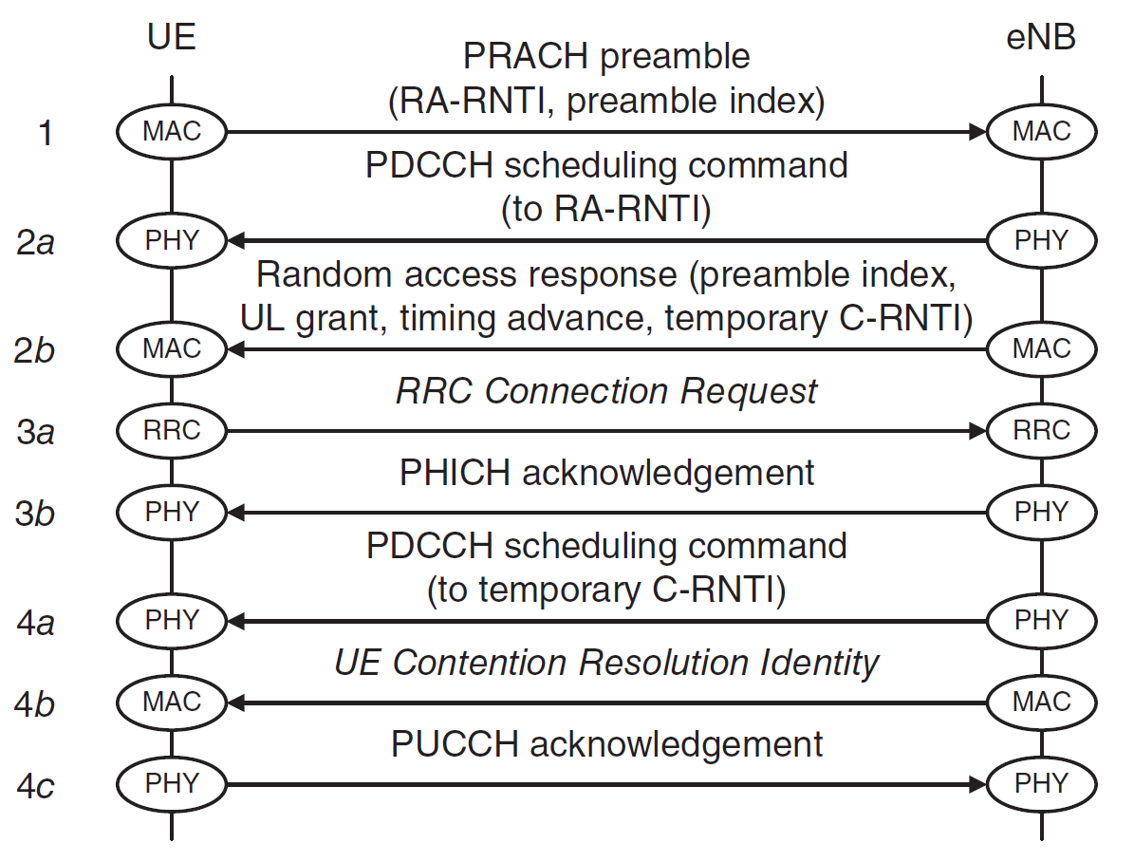

Figure 2 Contention-based random access procedure, as used during RRC connection establishment

*Resources*

<https://www.eventhelix.com/lte/random-access-procedure/lte-random-access-procedure.pdf>

<https://www.youtube.com/watch?v=FVjVe7SUYGU>

http://4g5gworld.com/category/glossary/crnti

## **Theory Questions**

1. What is the PUSCH? What is the PRACH? Which data is transmitted on which channel? (Base station to mobile and vice versa)
2. Why do we use a random access?
3. What is C-RNTI? Explain in your words.

## **Radio Resource Control (RRC)**

By preforming the random access procedure the mobile obtains a C-RNTI, an initial value for the timing advance and resources on the physical uplink shared channel (PUSCH) through which it can send a message to the network.

The mobile can then begin a procedure known as RRC connection establishment:

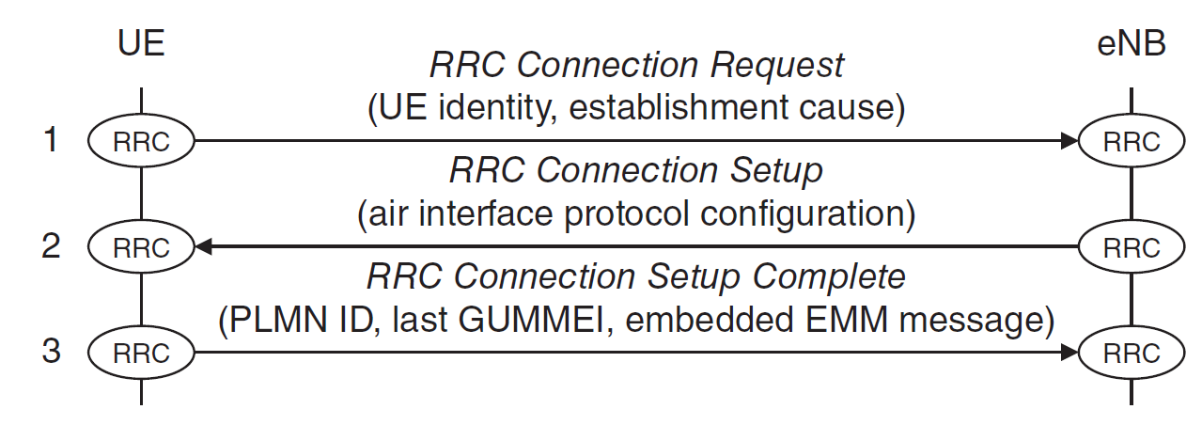

Figure 3 RRC connection establishment procedure. Source: TS 36.331. Reproduced by permission

In step 1, the mobile’s RRC protocol composes a message known as an RRC Connection Request. In this message, it specifies two parameters. The first is a unique non-access stratum (NAS) identity. The second is the establishment cause, which can be mobile originated signaling, mobile originated data, mobile terminated access (a response to paging), high priority access, or an emergency call. The message is sent on the common control channel, the uplink shared channel and the physical uplink shared channel. The base station reads the message, takes on the role of serving eNB and composes a reply known as an RRC Connection Setup (step 2). In this message, it configures the mobile’s physical layer and MAC protocols. The mobile reads the message, configures its protocols in the manner required and moves into RRC_CONNECTED. It then writes a confirmation message known as RRC Connection Setup Complete and transmits it back (step 3).

*Resources*

<https://en.wikipedia.org/wiki/Radio_Resource_Control>

<http://www.eventhelix.com/lte/attach/LTE-RRC-Connection-Setup-Messaging.pdf>

<https://en.wikipedia.org/wiki/Non-access_stratum>

https://www.3gpp.org/technologies/keywords-acronyms/96-nas

## **Theory Questions**

1. What are the radio resources we are controlling? Why it is needed to control these resources?
2. What is the intention in physical layer and MAC protocols configurations?
3. What is NAS?

## **Attach Procedure**

The attach procedure has four main objectives. The mobile uses the procedure to register its location with a serving MME. The network gives the mobile an IPv4 address and/or an IPv6 address and provides the mobile with always-on connectivity to a default PDN.

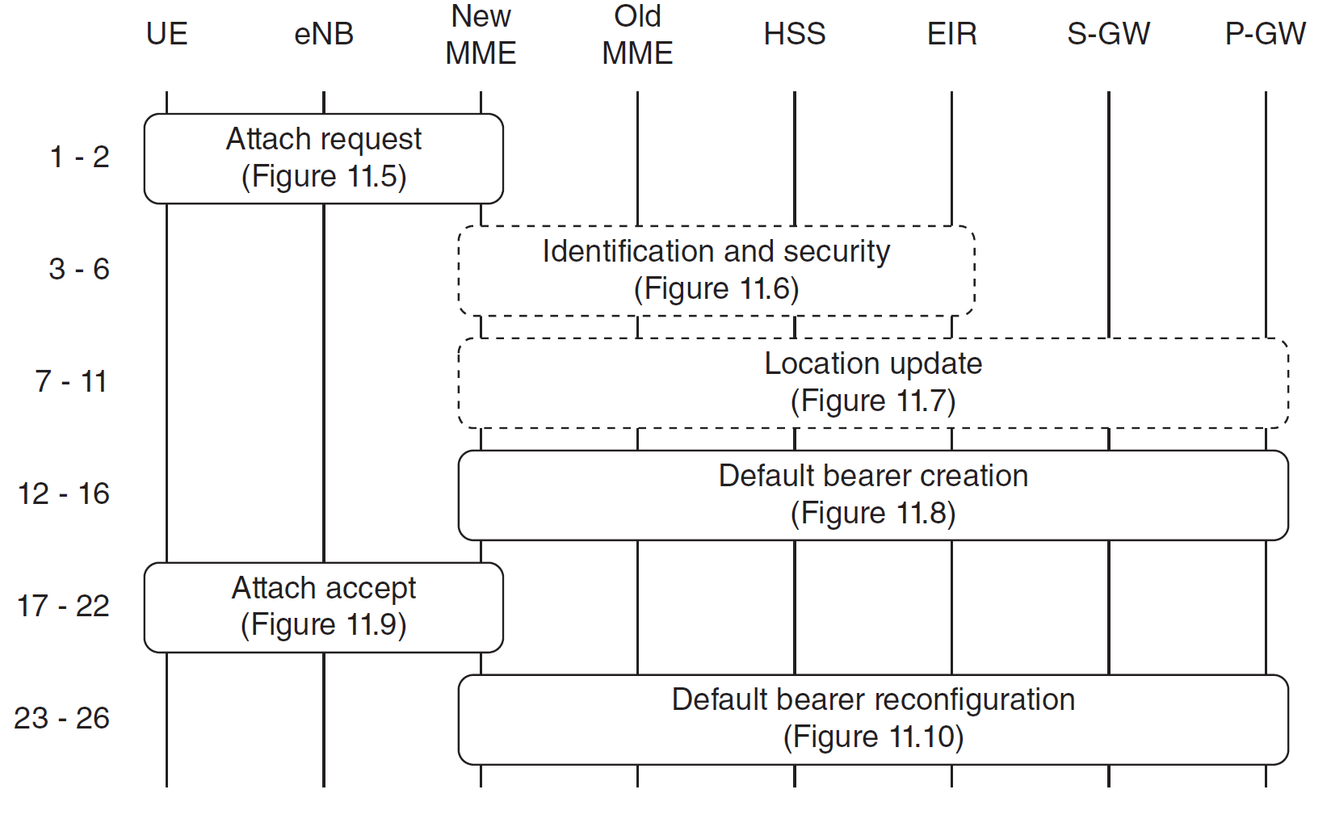

Figure 4 Overview of the attach procedure

## Attach Request

The mobile starts by running the contention-based random access procedure and the first two steps of RRC connection establishment, in the manner described earlier. The mobile then composes an EPS session management (ESM) message, PDN Connectivity Request, which asks the network to establish a default EPS bearer. The message includes a PDN type, which indicates whether the mobile supports IPv4, IPv6 or both. The mobile embeds the PDN connectivity request into an EMM Attach Request, in which it asks for registration with a serving MME. It also includes the mobile’s non-access stratum capabilities, primarily the security algorithms that it supports. In step 1 of the attach procedure, the mobile sends this message to the serving eNB.

*Resources*

<https://en.wikipedia.org/wiki/System_Architecture_Evolution>

<https://en.wikipedia.org/wiki/Public_data_network>

**Theory Questions**

1. What is the purpose of the ESM protocol? (EPS Session Management)
2. What is a PDN? Who are the PDNS you know of in Israel?
3. What is the Mobility Management Entity (MME)?

## **\*Identification, Security Procedures and Location Updates are optional and are not included in this document. Further information can be found in**

## [**An Introduction to LTE: LTE, LTE-Advanced, SAE and 4G Mobile Communications, Christopher Cox, Wiley, 2 edition (July 28, 2014), ISBN-13: 978-1118818039**](http://honorcup.ru/upload/iblock/542/542b5f58788c60b2864ffe71d920e820.pdf)

## Default Bearer Creation

The MME now has all the information that it needs to set up the default EPS bearer. It begins by selecting a suitable PDN gateway, using the mobile’s preferred APN if it supplied one and the subscription data support it, or the default APN otherwise. It then selects a serving gateway and sends it a Create Session Request. In this message, the MME includes the relevant subscription data and identifies the mobile’s IMSI and the destination PDN gateway. The serving gateway receives the message and forwards it to the PDN gateway. If the message does not contain a static IP address, then the PDN gateway can allocate a dynamic IPv4 and/or IPv6 address for the mobile. The PDN gateway can also run a procedure known as IP connectivity access network (IP-CAN) session establishment, during which it receives authorization for the default bearer’s quality of service.

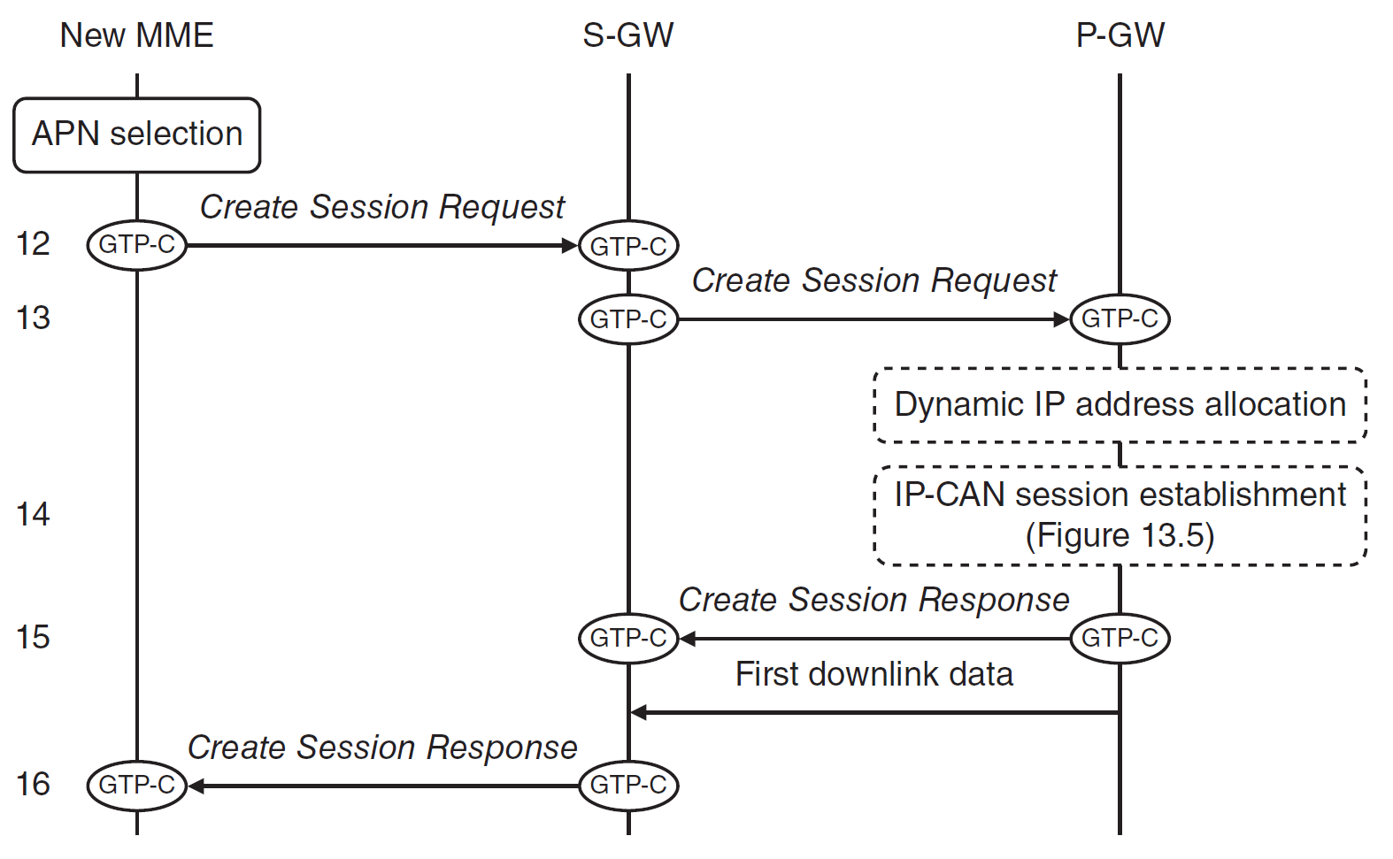

Figure 5Attach procedure. (4) Default bearer creation. Source: TS 23.401. Reproduced by permission

The PDN gateway now acknowledges the serving gateway’s request by means of a Create Session Response. In the message, it includes any IP address that the mobile has been allocated, as well as the quality of service of the default EPS bearer.

*Resources*

<https://en.wikipedia.org/wiki/System_Architecture_Evolution>

<https://en.wikipedia.org/wiki/Public_data_network>

<https://en.wikipedia.org/wiki/Access_Point_Name>

**Theory Question**

1. What is an APN? Why do we need it? What can we do with it? (Give at least 2 examples)
2. Why does the mobile send relevant subscription data to the MME?

## Attach Accept

The MME can now reply to the mobile’s attach request. It first initiates an ESM procedure known as Default EPS bearer context activation, which is a response to the mobile’s PDN Connectivity Request and which starts with a message known as Activate Default EPS Bearer Context Request. The message includes the EPS bearer identity, the access point name, the quality of service and any IP address that the network has allocated to the mobile. The MME embeds the ESM message into an EMM Attach Accept, which is a response to the mobile’s original attach request. The message includes a list of tracking areas in which the MME has registered the mobile and a new globally unique temporary identity. In turn, the MME embeds both messages into an S1-AP Initial Context Setup Request. This is the start of a procedure known as Initial context setup, which was triggered by the base station’s Initial UE Message. Afterwards the mobile can now send uplink data as far as the PDN gateway.

*Resources*

[*https://www.eventhelix.com/lte/tracking-area-update/lte-tracking-area-update.pdf*](https://www.eventhelix.com/lte/tracking-area-update/lte-tracking-area-update.pdf)

**Theory Question**

1. After attach accept, the mobile is connected to the LTE network. What kind of messages do you think the mobile will transmit? (include both control plane and data plane descriptions).
2. If the mobile is moving and becomes out of reach of its base station, describe what would you think needs to happen in order to keep a connection to the network?

That was enough theory, in the practical session you’ll find these procedures and messages when your mobile connects to the CSE LTE network.

# References

Main source

**[An Introduction to LTE: LTE, LTE-Advanced, SAE and 4G Mobile Communications](http://honorcup.ru/upload/iblock/542/542b5f58788c60b2864ffe71d920e820.pdf), Christopher Cox,**

**Wiley, 2 edition (July 28, 2014), ISBN-13: 978-1118818039**

Other sources

1. 3GPP TS 23.122 (2012) Non-Access-Stratum (NAS) Functions Related to Mobile Station (MS) in Idle Mode,

Release 11, December 2012.

2. 3GPP TS 36.304 (2013) User Equipment (UE) Procedures in Idle Mode, Release 11, September 2013.

3. 3GPP TS 23.401 (2013) General Packet Radio Service (GPRS) Enhancements for Evolved Universal Terrestrial

Radio Access Network (E-UTRAN) Access, Release 11, September 2013.

4. 3GPP TS 36.300 (2013) Evolved Universal Terrestrial Radio Access (E-UTRA) and Evolved Universal Terrestrial

Radio Access Network (E-UTRAN); Overall Description; Stage 2, Release 11, September 2013.

5. 3GPP TS 24.301 (2013) Non-Access-Stratum (NAS) Protocol for Evolved Packet System (EPS); Stage 3, Release

11, September 2013.

6. 3GPP TS 29.272 (2013) Evolved Packet System (EPS); Mobility Management Entity (MME) and Serving GPRS

Support Node (SGSN) Related Interfaces Based on Diameter Protocol, Release 11, September 2013.

7. 3GPP TS 29.274 (2013) 3GPP Evolved Packet System (EPS); Evolved General Packet Radio Service (GPRS)

Tunneling Protocol for Control Plane (GTPv2-C); Stage 3, Release 11, September 2013.

8. 3GPP TS 36.331 (2013) Radio Resource Control (RRC); Protocol Specification, Release 11, September 2013.

9. 3GPP TS 36.413 (2013) Evolved Universal Terrestrial Radio Access Network (E-UTRAN); S1 Application Protocol

(S1AP), Release 11, September 2013.

10. 3GPP TS 23.122 (2012) Non-Access-Stratum (NAS) Functions Related to Mobile Station (MS) in Idle Mode,

Release 11, Sections 3.1, 4.3.1, 4.4, December 2012.

11. 3GPP TS 36.304 (2013) User Equipment (UE) Procedures in Idle Mode, Release 11, Sections 4, 5.1, September

2013.

12. 3GPP TS 31.102 (2013) Characteristics of the Universal Subscriber Identity Module (USIM) Application, Release

11, Sections 4.2.2, 4.2.5, 4.2.53, 4.2.54, 4.2.84, 4.2.91, September 2013.

13. 3GPP TS 31.102 (2013) Characteristics of the Universal Subscriber Identity Module (USIM) Application, Release

11, Section 4.4.6, September 2013

All websites above